🚀 Project Status: AI Model Optimization
Note: This document demonstrates the power of AI2Word.
Notice how Tables, Math, Code, and Diagrams are formatted perfectly for professional reports.

1. Executive Summary
We have successfully reduced the inference latency by 45% while maintaining accuracy. The new architecture uses quantization-aware training.

2. Performance Metrics (Table Support)
Comparison between the baseline model and the optimized version:
Metric | Baseline (v1.0) | Optimized (v2.0) | Improvement
Latency | 120ms | 65ms | ✅ -45.8%
Accuracy | 98.2% | 98.0% | ➖ -0.2%
Model Size | 500MB | 120MB | ✅ -76.0%

3. Mathematical Foundation (Native LaTeX)
The loss function includes a regularization term to prevent overfitting.
(Double-click the formula in Word to edit it directly!)
$$ℒ(θ)=−\frac{1}{N}\sum_{i=1}^{N}{\left[y_{i}\text{log}({\hat{y}}_{i})+(1−y_{i})\text{log}(1−{\hat{y}}_{i})\right]}+λ||θ||^{2}$$

4. Implementation Details (Code Highlighting)
We implemented a custom layer for dynamic attention:
import torch.nn as nn
class DynamicAttention(nn.Module):
def __init__(self, dim):
super().__init__()
# Initialize scale factor
self.scale = dim ** -0.5
def forward(self, x):
# AI2Word preserves syntax highlighting
return x * self.scale

5. Workflow Diagram (Mermaid Support)
The data processing pipeline is visualized below. Note the custom styling on the final node:
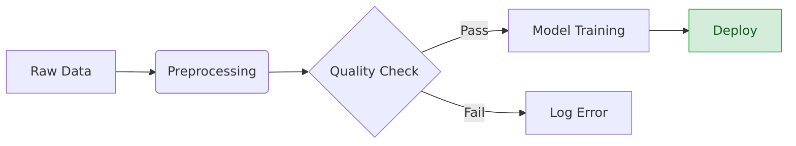

Code Block
type User = { id: string; name: string };
const hello = (u: User) => 'Hello, ' + u.name + '!';
pnpm install
pnpm dev

复杂公式
这里是麦克斯韦方程组的积分形式：
∂Σ​E⋅dℓ=−Σ​∂B∂t⋅dS
这里是一个多行对齐的推导过程：
$$\begin{aligned}f(x)&=(x+a)(x+b) \\ &=x^{2}+(a+b)x+ab \\ &≈x^{2} \text{if}x≫a,b\end{aligned}$$
这里是一个矩阵和分段函数：
$$X=\left[\begin{matrix}1 & x & x^{2} \\ 1 & y & y^{2} \\ 1 & z & z^{2}\end{matrix}\right], f(n)=\left\{\begin{matrix}n/2 & \text{if}n\text{is even} \\ 3n+1 & \text{if}n\text{is odd}\end{matrix}\right.$$
Note: These formulas are exported as Native Word Objects (OMML). You can double-click them in Word to edit numbers or symbols directly. No images, no fuzziness.
支持以下 12 种主流 Mermaid 图表，从基础流程图到专业架构图。

1. 流程图 (Flowchart)
最常用的逻辑判定与路径跳转图表。
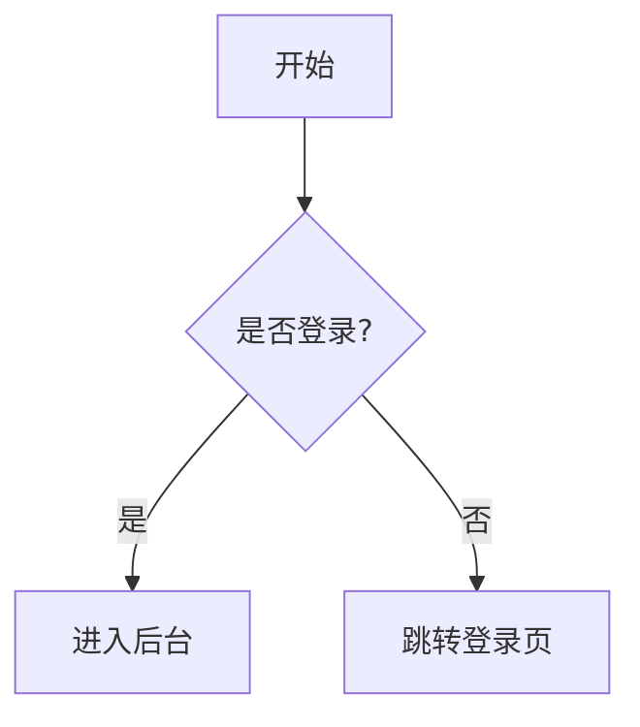

2. 时序图 (Sequence Diagram)
展示对象交互顺序，支持 alt 分组与虚线返回。
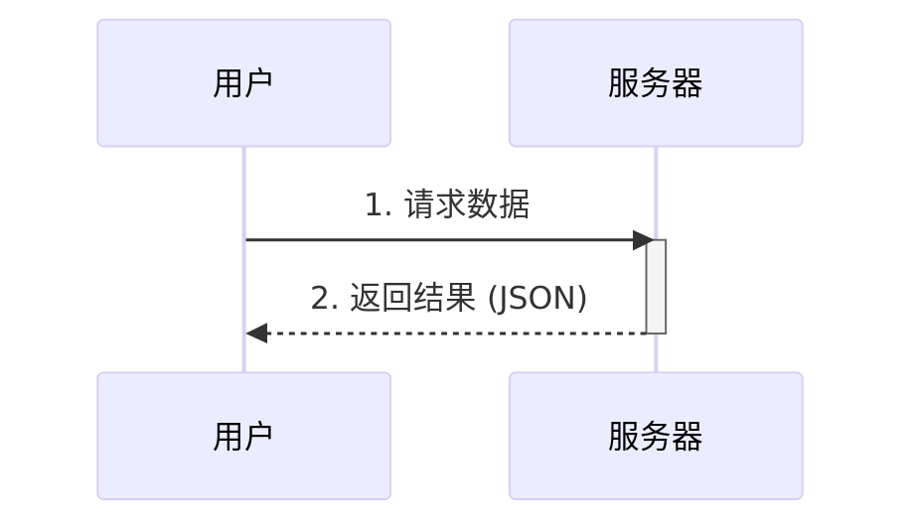

3. C4 架构图 (C4 Context) - Pro 核心功能
专为系统架构师打造，完美渲染系统边界 (System Boundary) 与技术栈标注。
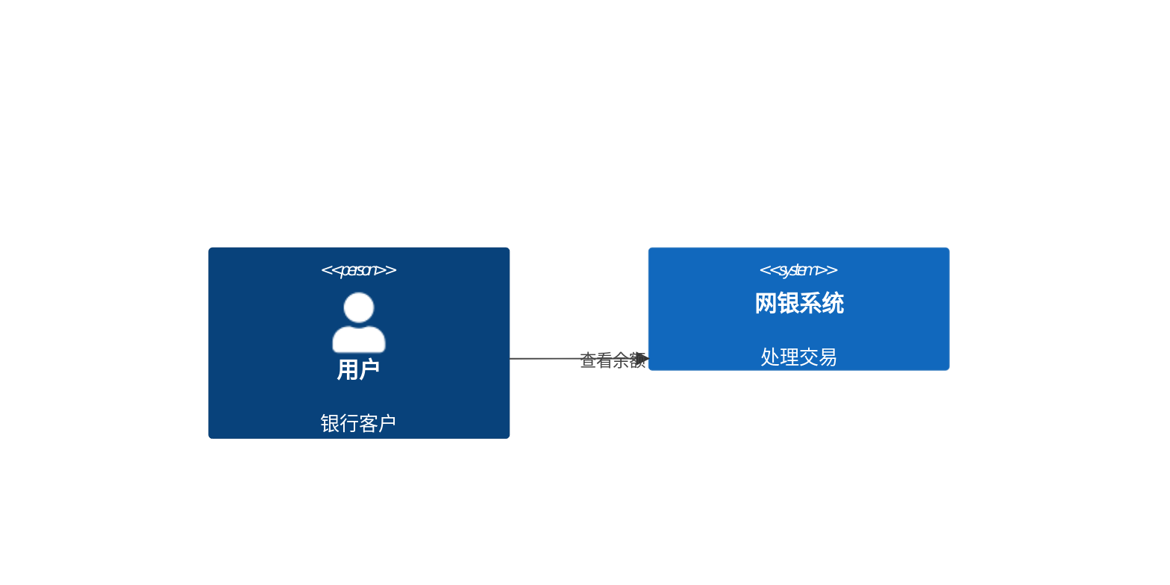

4. 甘特图 (Gantt Chart)
项目进度管理神器，支持日期轴自动排版与任务状态高亮。
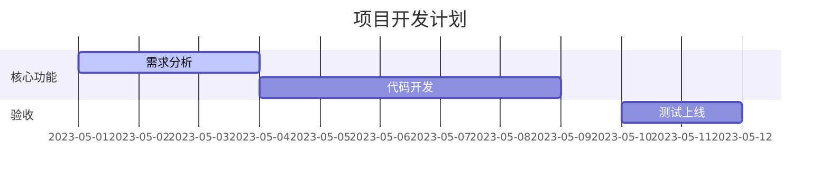

5. 类图 (Class Diagram)
面向对象编程建模，支持继承、聚合等复杂关系。
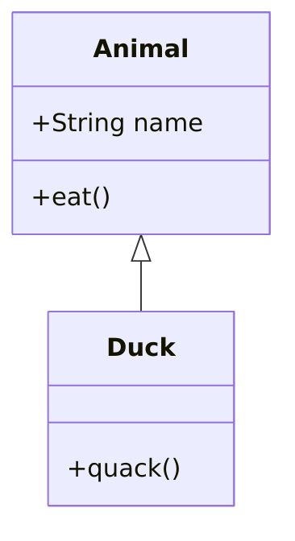

6. 状态图 (State Diagram)
展示系统或业务流程的状态流转。
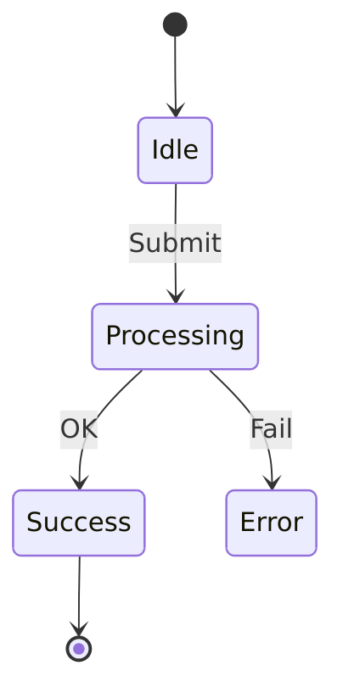

7. 实体关系图 (ER Diagram)
数据库建模专用，清晰展示一对一、一对多关系。
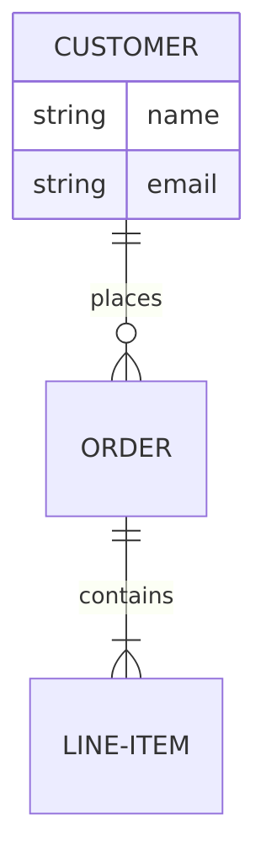

8. Git 提交图 (Git Graph)
版本控制流展示，支持多分支颜色区分与合并节点。
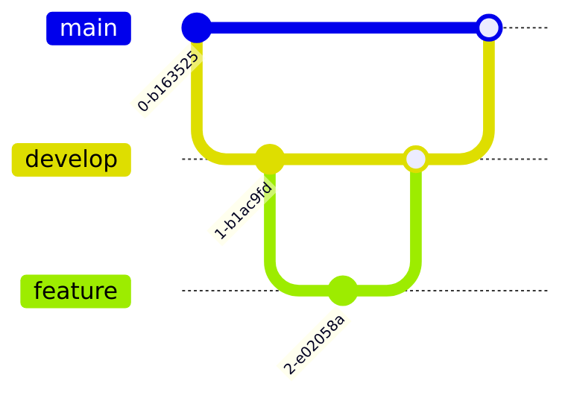

9. 用户旅程图 (User Journey)
产品体验与交互分析，支持表情符号渲染。
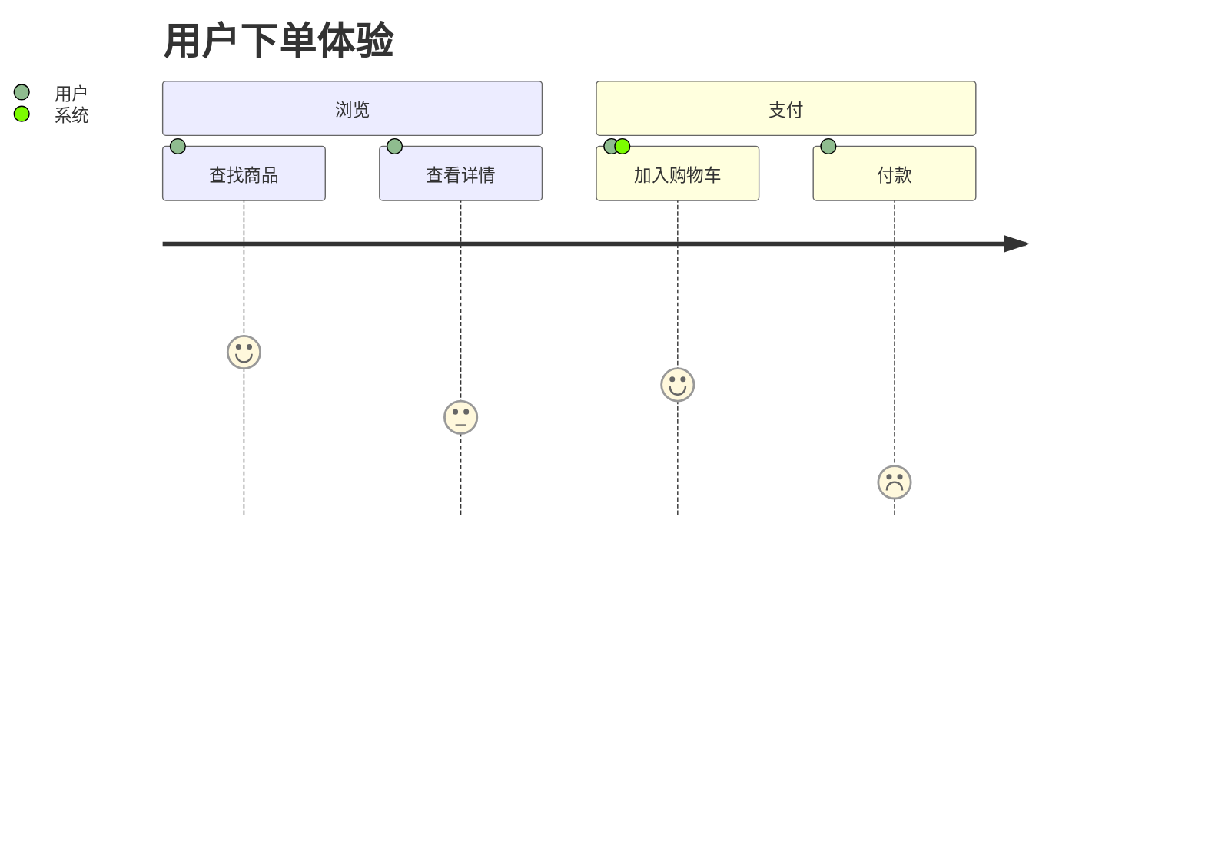

10. 思维导图 (Mindmap)
层级结构展示，适合头脑风暴与组织架构。
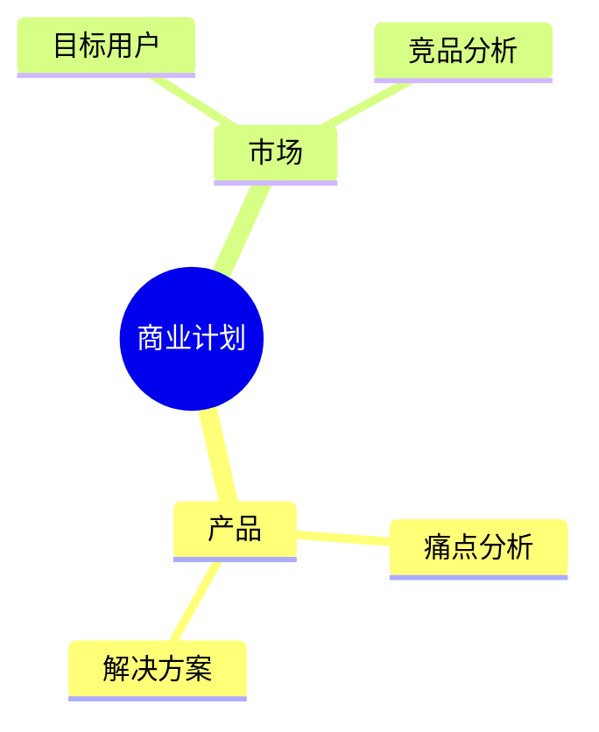

11. 饼图 (Pie Chart)
数据统计分布可视化。
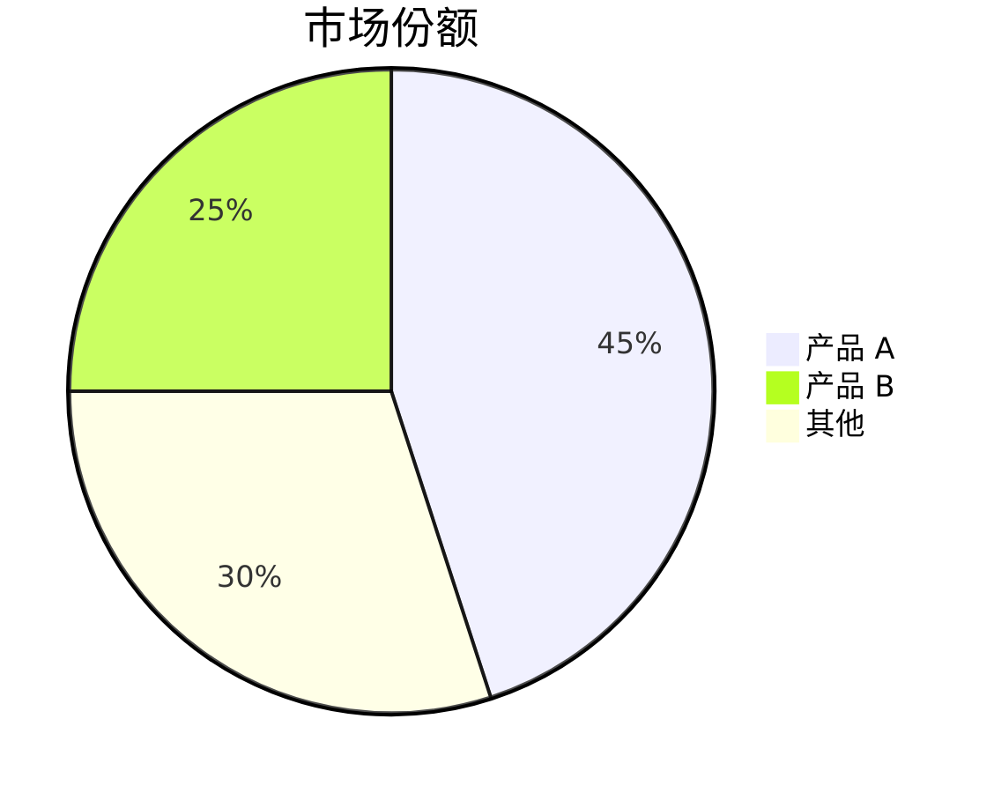

12. 桑基图 (Sankey Diagram)
流量、能源或资金流向分析。
